Project Proposal

* We are going to develop an app named **sky wings**
* The problem or the issue we are going to address is to help the customer to book the flight ticket

Easily to their desired destination. Many of the current platforms are overloaded with features that impede users' ability to find and book flights quickly. Furthermore, some platforms don't disclose prices or available options clearly, which irritates users and wastes their time.

* **Activities that we are going to create is**

**User Authentication and login**:  
  
Goal: Enables users to register for a new account or sign in with their current login information. User information, including name, email address, and preferences, will be stored.  
Data: Personal (name, email), preference (preferred airlines, preferred seating), and authentication details (password, username) of the user.  
  
**Search for Flights**:  
  
Goal: Allows customers to look for flights according to their budget, date, and destination preferences.  
Information: Search history, flight preferences (dates, departure and arrival locations, preferred classes), and search results for the user.  
See the flight information:  
  
The goal is to give users comprehensive details about specific flights, such as cost, airline, arrival and departure times, and amenities offered.  
Data: User viewing history, flight details (price, airline, arrival/departure times, and amenities).  
inclinations.

**flight information**:   
  
 The goal is to give users comprehensive details about specific flights, such as cost, airline, arrival and departure times, and amenities offered.  
 Data: User viewing history, flight details (price, airline, arrival/departure times, and amenities).   
  
 **Booking a Flight**:   
  
 Goal: Simplifies the booking process so that customers can pay and confirm the flight they want to take.   
 Data: Booking history for the user, credit card payment information, and confirmation details.

* **Rough sketch of the activities that we are going to create and the flow between them**

**User Authentication/Login**:

Sketch: A screen showing fields for username/email and password with options for login or sign up.

Flow: Upon entering credentials and selecting login/signup, the app should authenticate the user and proceed to the home screen.

**Search for Flights**:

Sketch: A screen with input fields for departure or arrival locations, dates, and class preferences, along with a search button.

Flow: After entering search criteria and clicking the search button, the app should display a list of available flights.

**View Flight Details**:

Sketch: A screen displaying detailed information about a selected flight, including price, departure or arrival times, airline, and amenities.

Flow: When a user selects a flight from the search results, the app should navigate to this screen to show detailed flight information.

**Book Flight**:

Sketch: A screen showing the selected flight details and fields for entering payment information credit card details and a confirm booking button.

Flow: After reviewing the flight details and entering payment information, the user can confirm the booking, leading to the confirmation screen.

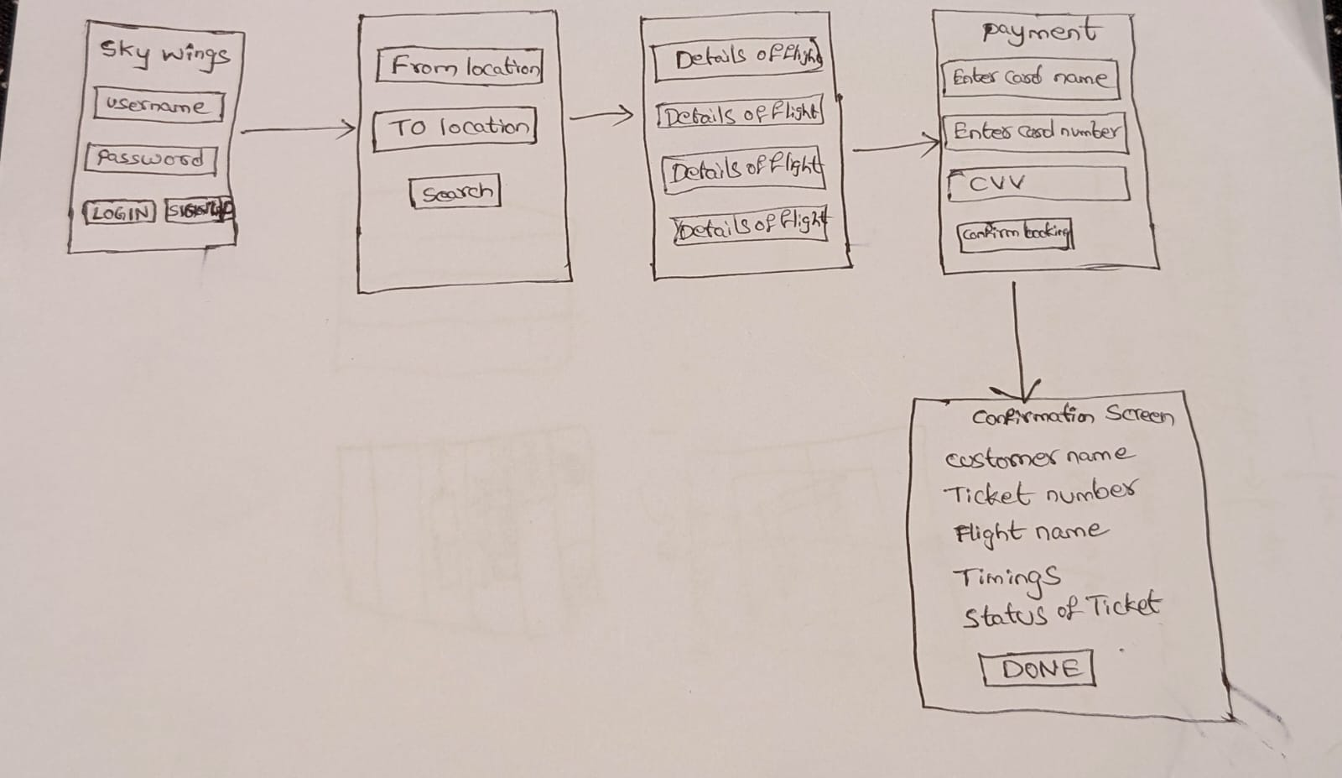

* **For persistence on the app, we want to store data such as**:

**App Settings**: user-configurable settings such as language preferences, notification preferences, or default search criteria.

**Booking History**: Information about past flight bookings made by the user. This data would be tied to the user's account and would need to be stored securely to provide access to the user across different sessions.

* **For data sharing across different users of the app, examples could include**:

**Flight Availability**: Information about available flights, prices, and schedules. This data would need to be shared across all users of the app in real-time to ensure accurate search results.

**Promotions/Deals**: Special offers or discounts on flights that are available to all users of the app. This data would need to be shared across all users to ensure equal access to promotional opportunities.

Team Members:

**Srikanth Boppudi**

**Tejaswini Pydipally**

**Nikitha Sree Atluri**

**Maheswarreddy Polam**